L12: Activity Reflection (Learning Journal)
After completing the activity, fill in the table below.
Instructions
- Choose two features from your website
(e.g. form submission, req.body, passing data, displaying data, Bootstrap layout)
- Copy 3–6 lines of code related to that feature.
- Write 1–2 sentences explaining what the code does.
Feature Used  Navbar / Grid / Card / any bootstrap feature | AI Prompt Used  Write the prompt you used | Code Generated by AI  Screenshot a small section of the code related to the feature | What I Modified  Describe what you changed | What This Code Does  Explain what the code does
Example:  Handling form submission (POST route) | How do I handle form submission in Express and display the data on another page? | 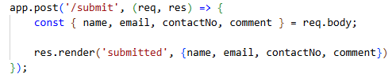 | Changed variable names to match my form fields. | Gets form data from req.body and sends it to the confirmation page
 | How to display data in a table format | 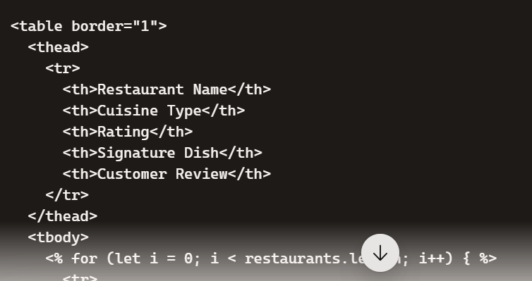 | I changed the variables names according to my dataset | It loops through the restaurants array passed from the Express backend. For each restaurant object, it generates one (table row). Each property (into a <td> (table cell).
Handling success page after form submission | How do I show a success page after submitting a form in Express? |  | Added my own comment and used <strong> to bold the label “Restaurant Name” | Displays the restaurant’s name on the success page, with the label emphasized in bold for clarity

